

**Course Name**: PRIN ELECT ENG I LAB

**Course Number and Section**: **14:332:223:01**

**Experiment**: Lab 1 Post Lab

**Lab Instructor**: ANASTASIOS KLENIATIS

**Date Performed**: 10/7

**Date Submitted**: 10/20

**Submitted by**: Chance Reyes 225006531

Reah Robinson 222005697

**1. Analysis for experiment 1.1:**

**a.** Use the resistor tolerance to calculate the range of potential values for the resistor used in the experiment. For example, a 1kΩ± resistor can have a resistance in the range of 0.9 kΩ to 1.1 kΩ.

**Resistor tolerance: Gold - 5 %**

**Range of potential values:**

**220** Ω **— range from 209**Ω **to 231** Ω

**2.2k**Ω **– range from 2.09k** Ω **to 2.31**Ω

**b.** Plot your current and voltage measurements using excel where x-axis represents and y-axis represents v.

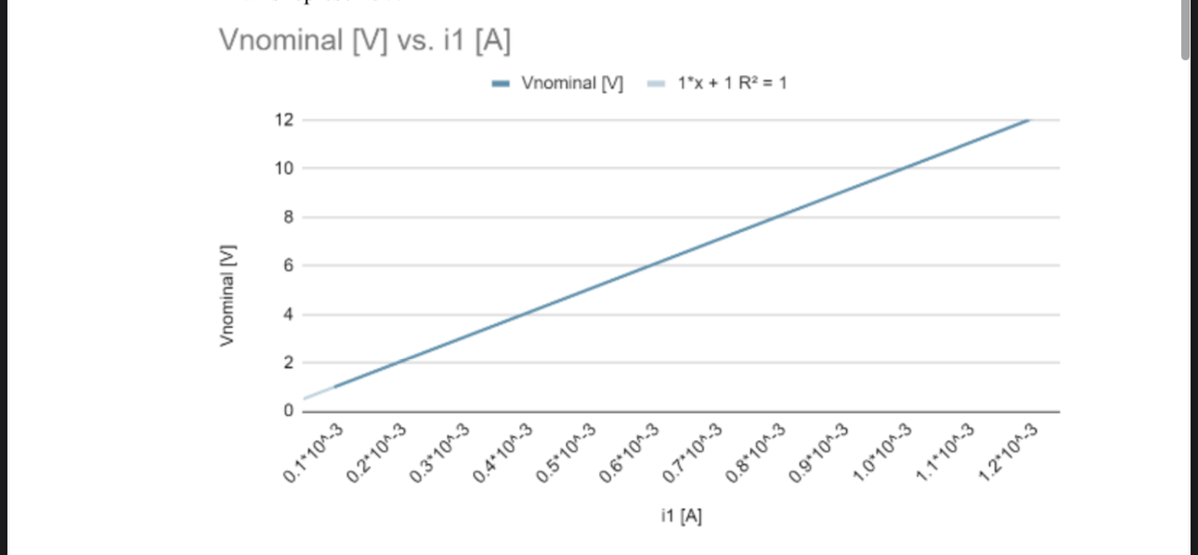

**c.** Calculate R for each pair of measured current and voltage and find the average values for R.

**Average Value of R = 1200 Ohms**

**d.** Discussion: compare the average measured value with the DMM resistance measurement and the color-coded value. Is it within the resistance tolerance range?

**Yes, the DMM resistance measurement and the colors coded value is within the same range.**

**2.** Analysis for experiment 1.2:

**a.** Provide code file used with Arduino.

**https://drive.google.com/file/d/1OCAhr7T-kaow70weT3-M8cZqJWku1dsk/view?usp=drive_link**

**b.** Analog I/O A0 and A1 measure the node voltage on each side of the resistor and thus the difference between them represent the voltage drop across the resistor. Find the voltage drop across the R 1 resistor for both cases (220Ω to 2.2kΩ) by averaging the 10 measurements obtained in experiment 1.2.

**Case 1: 3.38V**

**Case 2: 3.49V**

**c.** Compare the Arduino averaged measurement to the DMM voltage measurements for both cases.

**Case 1: Arduino: 3.38V DMM: 3.28V**

**Case 2: Arduino: 3.49V DMM: 3.3V**

**d.** Calculate the current flowing through the resistor R 1 for both cases using the DMM measurements for voltage and resistance.

**Case 1: Arduino: 0.0016A DMM: 0.0015A**

**Case 2: Arduino: 0.015A DMM: 0.015A**

**e.** Calculate the power generated by the 5V source on the Arduino for both cases, given that the current flow through the resistor is the same as the current flowing out of the source.

**Case 1: 0.0079W**

**Case 2: 0.077W**

**f.** How much power does the LED consumes in each case?

**Case 1: 0.0026W**

**Case 2: 0.022W**

**g.** Discussion: the current flowing through the resistor is equal to the current flowing through the LED and the current flowing from the 5V source on the Arduino.

• Compare the results for the current flowing through the LED with the light intensity for both R 1 values. How did the current change between the cases and how does it relate to the light intensity?

**When using a lower resistance, the light intensity of the LED will be greater.**

• How does the power, consumed by the LED, change between the two cases?

**The LED will consume more power if the light is more intense.**

**3. Simulation:**

**a.** Develop a LTSpice model for the circuit given in Figure 13.

[**https://drive.google.com/file/d/1tdXa1Fe_reGJKoOygGgIEPFeUgquhv52/view?usp=drive_link**](https://drive.google.com/file/d/1tdXa1Fe_reGJKoOygGgIEPFeUgquhv52/view?usp=drive_link)

**b.** Find voltage, current, and power for each element in the circuit (all resistors and sources) using the LTSpice model.

| Component | Voltage (V) | Current (mA) | Power (mW) |
| --- | --- | --- | --- |
| V1 | 5V | 0.625 | -3.125 |
| R1 | -0.625 | 0.625 | 0.391 |
| R2 | -1.875 | 0.625 | 1.172 |
| R3 | -2.5 | 0.417 | 1.042 |
| R4 | -0.42 | 0.208 | 0.086 |
| R5 | -2.08 | 0.208 | 0.434 |

**c.** Use the power balance equation to verify your results.

**-3.125 + 0.391 + 1.172 + 1.042 + 0.086 + 0.434 = 0**

**d.** Include the LTSpice simulation with your submission.

[**https://drive.google.com/file/d/1LBGTmu1MxdFPtHtvwDyFbgrI0l8ctIxF/view?usp=drive_link**](https://drive.google.com/file/d/1LBGTmu1MxdFPtHtvwDyFbgrI0l8ctIxF/view?usp=drive_link)

**e.** Develop a TinkerCAD model for the circuit in Figure 13.

**See part G**

**f.** Connect a voltage meter to measure the voltage drop across R1 and R2.

**See part G**

**g.** Provide a URL to your TinkerCAD simulation and a PDF of the schematic.

[**https://www.tinkercad.com/things/jWwwPIUfDWS-chancereyestinkercadfigure13?sharecode=hXmIRsG2JRNwkYI3-0XWZJJin4DnEV1GqkkdaC5TzzM**](https://www.tinkercad.com/things/jWwwPIUfDWS-chancereyestinkercadfigure13?sharecode=hXmIRsG2JRNwkYI3-0XWZJJin4DnEV1GqkkdaC5TzzM)

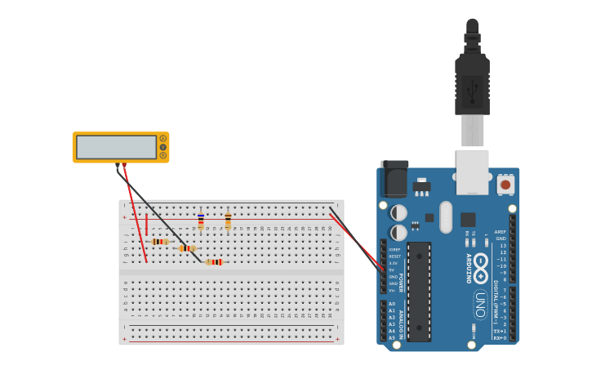

**4. Images:**



